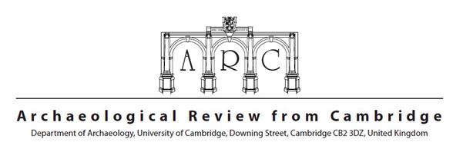
INSTITUTIONAL SUBSCRIPTION FORM

Institutional Details
Name of Institution

Name of individual contact (if any)
Address to which issue(s) should be sent

Postcode

Country

Address to which renewal invoices and correspondence should be sent

Subscription Details
 |  | Quantity | Total (in £)
Subscription for 2022  Volume 37  (Issues 37.1 and 37.2) | UK (£70)  Rest of the world (£90)

For more details of past, current and future issues, see http://arc.soc.srcf.net/.
Please print this form and send it to the address above with payment enclosed. Please write clearly. Payment can be made via cheque or paid online at http://arc.soc.srcf.net/subscriptions.html. Cheques should be in pounds sterling and made payable to Archaeological Review from Cambridge. Please send the completed form along with payment to the address provided. Subscriptions can only be cancelled upon expiry, not mid-term.

